Part 1 a

**def test_nhi_phan(a):**

**if(a == '0000' or a== '0001' or a == '0010' or a== '0011' or a == '0100' or a== '0101' or a == '0110' or a== '0111' or a == '1001'):**

**return True**

**else:**

**return False**

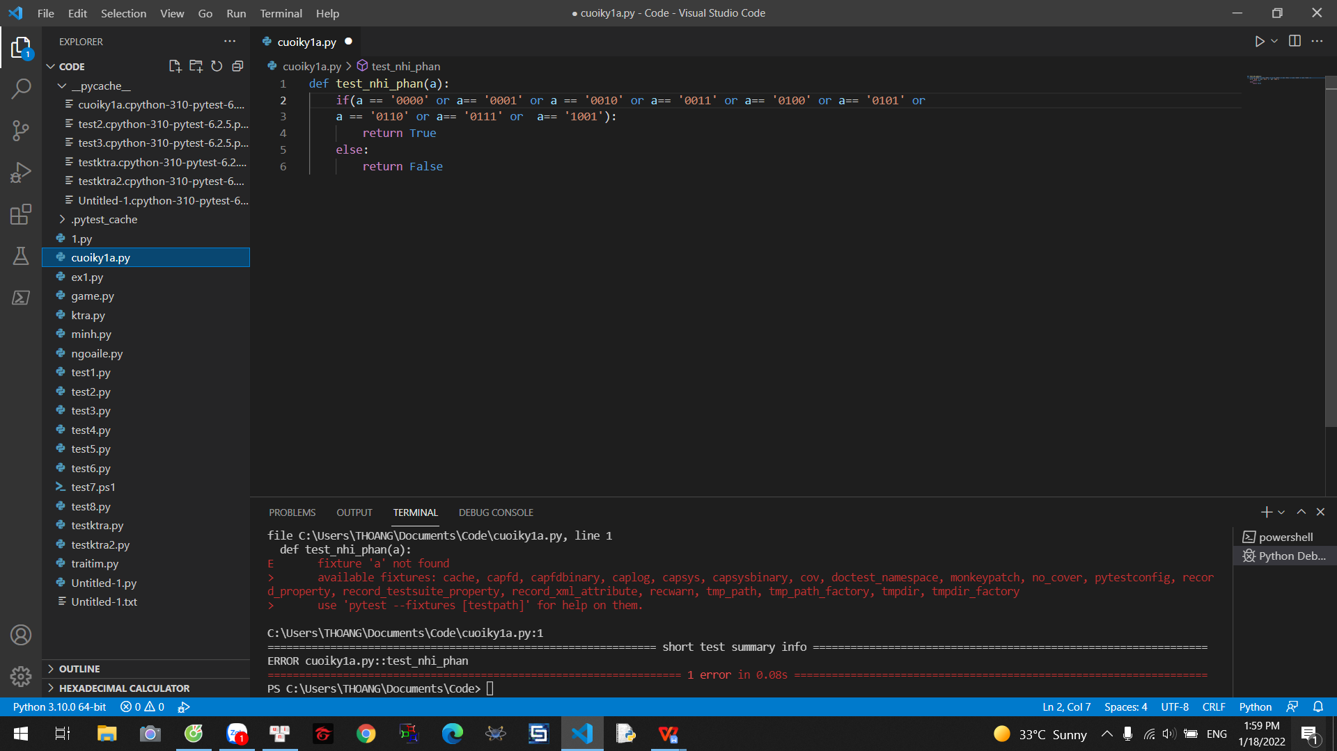

**Part2.**

Question 2

-SELECT SUM (commission), SALESMAN.CITY

FROM SALESMAN

GROUP BY CITY

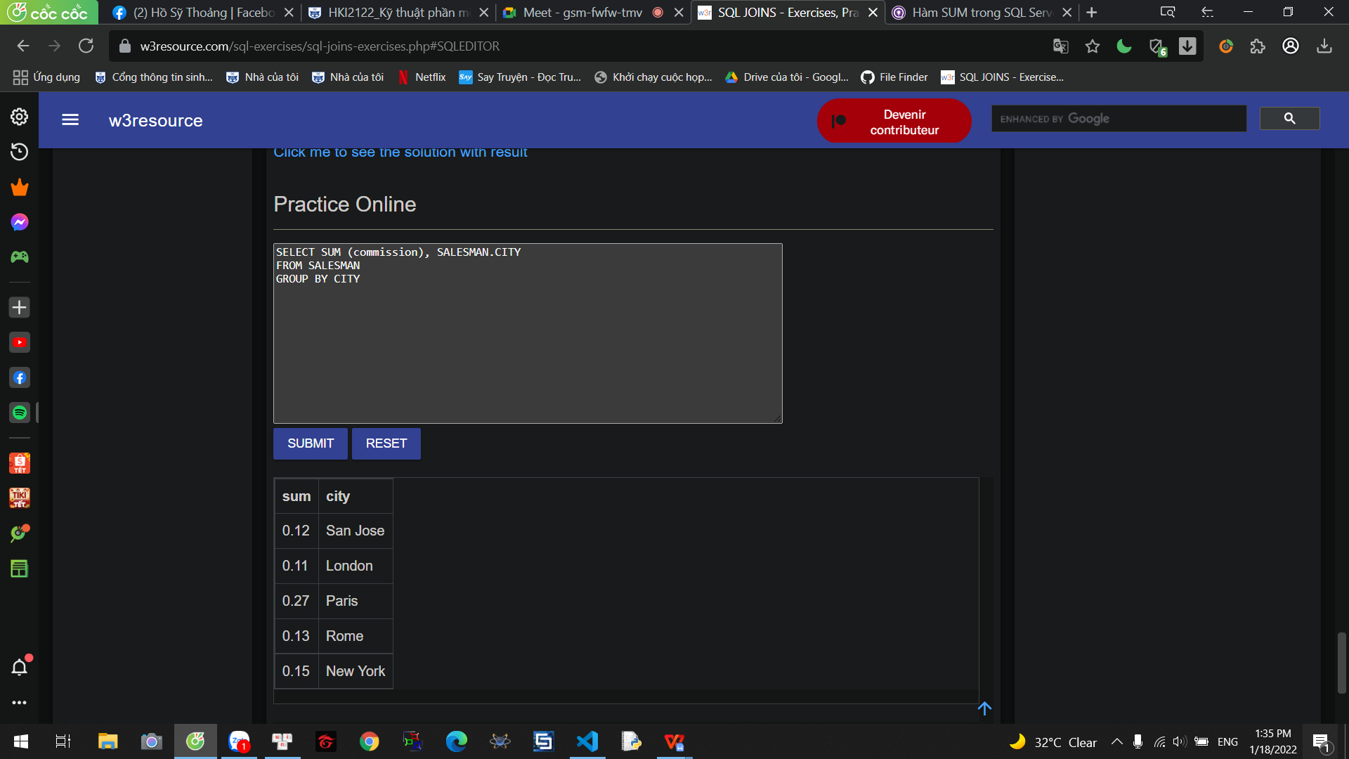

**-SELECT a.cust_name AS "Customer Name",**

**a.city, b.name AS "Salesman", b.commission**

**FROM customer a**

**INNER JOIN salesman b**

**ON a.salesman_id=b.salesman_id**

**WHERE b.commission>.12;**

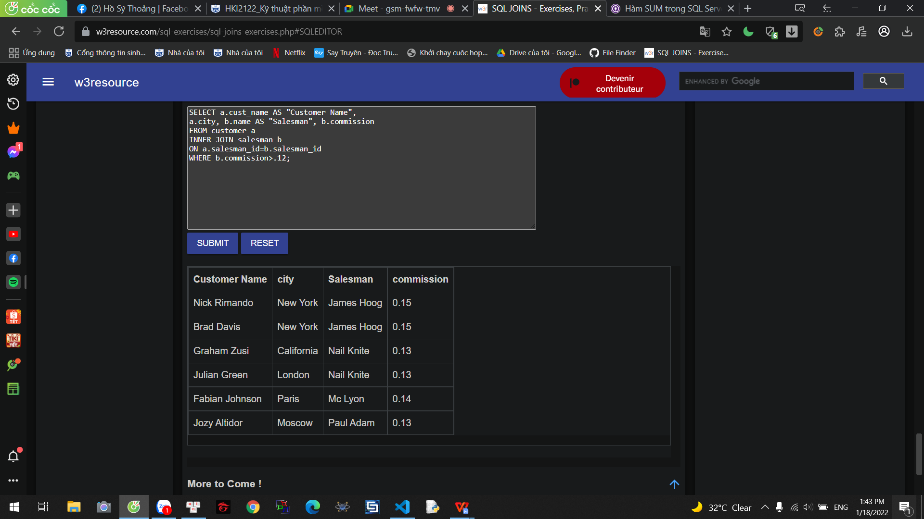

PART2 1

**import math**

**class Real_Number:**

**def __init__(self, real_number):**

**self.real_number = real_number**

**def module(self):**

**return abs(self.real_number)**

**class Complex_Number(Real_Number):**

**def __init__(self, real_number, image_number):**

**super().__init__(real_number)**

**self.image_number = image_number**

**def module(self):**

**return math.sqrt((self.real_number * 2) + (self.image_number * 2))**

**num = Complex_Number(10, 3)**

**print(num.module())**

